

DEPARTMENT OF COMPUTER & SOFTWARE ENGINEERING
COLLEGE OF E&ME, NUST, RAWALPINDI

CS-117 Applications of ICT

LAB MANUAL – 06

Course Instructor: Dr. Soyiba

Lab Instructor: Engr Moiz Shahid

Student Name: _______________________________________________

Degree/ Syndicate: ____________________________________________

LAB # 06: Python Libraries

Lab Objective:
The main objective of this lab is to familiarize students with essential Python libraries used for data manipulation, numerical computation, and data visualization. By working with these libraries, students will learn how to efficiently handle large datasets, perform mathematical operations, and create insightful visual representations of data. Additionally, the lab will help students understand how to preprocess, clean, and transform data for analysis, as well as interpret patterns and trends through visual tools. This foundational knowledge is crucial for building skills in data analysis, scientific computing, and machine learning applications.

Hardware/Software Tools:
- Hardware: Desktop/Computer
- Software Tool: Python IDLE/Google Colab

Lab Description:
This lab focuses on introducing students to the core Python libraries that serve as the backbone of modern data analysis and scientific computing. Students will explore libraries such as NumPy, Pandas, and Matplotlib to perform tasks related to numerical computation, data manipulation, and visualization. Through hands-on exercises, they will learn how to efficiently manage and process large datasets, perform mathematical and statistical operations, and create meaningful visual representations of data. The lab aims to build a strong foundation in practical data handling and analysis techniques, preparing students for advanced topics such as machine learning, data science, and predictive modeling.

Python Libraries:
In Python, a library is a collection of pre-written code that provides ready-to-use functions and tools to perform specific tasks such as data analysis, visualization, or mathematical operations without having to write the code from scratch. NumPy (Numerical Python) was developed to provide fast and efficient operations on large arrays and matrices of numerical data. It serves as the foundation for most scientific computing tasks in Python. With NumPy, users can perform mathematical operations, such as addition, subtraction, trigonometric functions, and linear algebra computations, directly on arrays without writing complex loops. It’s optimized for performance, making numerical computations faster and more memory-efficient than standard Python lists.

Pandas was created to simplify data manipulation and analysis. It introduces powerful data structures like DataFrame and Series, which make it easier to clean, filter, reshape, and aggregate data. Pandas is particularly useful for working with tabular data (like Excel sheets or CSV files) and is often used in data preprocessing before applying machine learning algorithms. It helps users handle missing data, perform statistical analysis, and merge multiple datasets efficiently. Matplotlib is a comprehensive data visualization library that allows users to create a wide range of plots and charts, such as line graphs, bar charts, histograms, and scatter plots. It also supports advanced visualizations like 3D plots and animations. With Matplotlib, users can transform raw numerical data into clear, interpretable visual representations, which helps in identifying patterns, relationships, and trends within the data.

Example:
Think of Python libraries as a real library full of books:
- NumPy is like the section of math and calculation books in a library it gives you all the tools you need to perform fast and complex numerical computations. Instead of solving every equation manually, you can “borrow” ready-made mathematical methods from NumPy.
- Pandas is like the organizational system in the library it helps you organize, sort, and manage your books (data) efficiently. If you have books scattered everywhere (raw data), Pandas helps you arrange them into shelves (DataFrames) so you can easily find or analyze them.
- Matplotlib is like the display section of the library where information is shown visually, such as posters or infographics. It helps you to present data in a visual and understandable way, just like a chart or diagram explaining book categories or visitor trends in the library.

Syntax:
import [Library Name] as [alias]
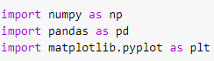
Dot operator (.) is used to access the library functions. For example:
np. [required function]
pd. [required function]
plt. [required function]
Numerical Python (Numpy):
NumPy is a Python library that makes working with numbers and large sets of data easier. It allows us to create arrays (like lists) that can hold many numbers and perform fast mathematical operations on them. It’s like a supercharged calculator that helps you work with many numbers at once. Some key features of NumPy are given as:
- NumPy uses arrays instead of lists because they take up less space and are faster for calculations.
- NumPy provides a lot of built-in functions to perform operations like addition, multiplication, finding maximum values, mean, median etc.

Example No. 01:
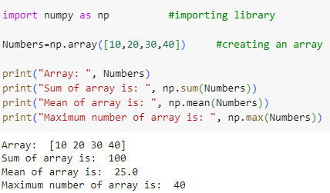
Example No. 02:
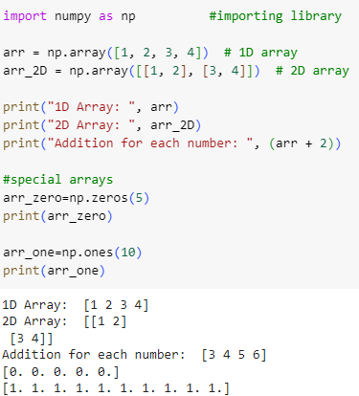

Example No. 03:
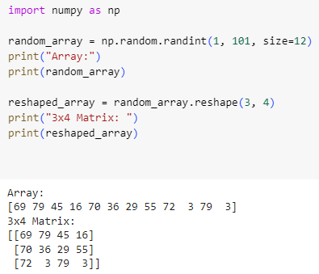
NumPy helps you work with numbers and perform complex calculations quickly, using simple and powerful functions.
Pandas:
Pandas is a Python library that makes it easy to work with data, especially when dealing with tables or spreadsheets. It helps us clean, organize, and analyze data, whether it’s from a file like CSV, Excel, or entered manually. Pandas can manage large amounts of data efficiently and provides powerful tools for filtering, grouping, merging, and summarizing information. It also integrates seamlessly with other libraries like NumPy and Matplotlib, making it a key component in data analysis and machine learning workflows.
Data Structures:
Pandas mainly use two types of data structures.
- Series: A list like a single column.
- DataFrame: A table like a spreadsheet with rows and columns.

Example No. 01:
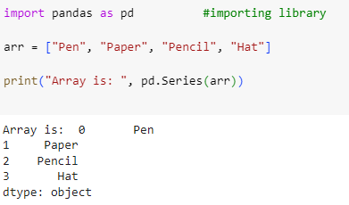
Example No. 02:
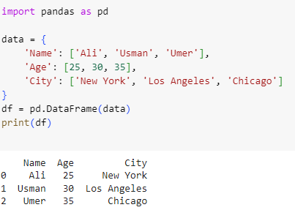
Matplotlib:
Matplotlib is a Python library used to create graphs and charts. It helps us visualize our data, so we can easily understand patterns, trends, or comparisons. Whether we want to make simple line graphs or more detailed bar charts, Matplotlib gives us the tools to do that. It helps us see the data through charts, making it easier to explain and understand. It is widely used in data science and research. We can customize graphs by adding labels, colors, titles, and more.
Main Functions in Matplotlib:
- plot ( ) is used to create line graphs.
- bar ( ) is used to create bar charts.
- scatter ( ) is used to create scatter plots.
- hist( ) is used to create histogram.
- show ( ) is used to display the plot.
- xlabel ( ) is used to label x-axis.
- ylabel ( ) is used to label y-axis.
- title ( ) is used to give title to the graph.
Example No. 01:
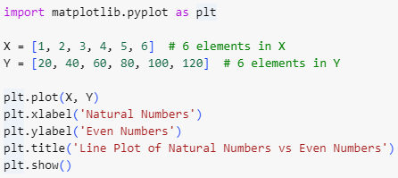
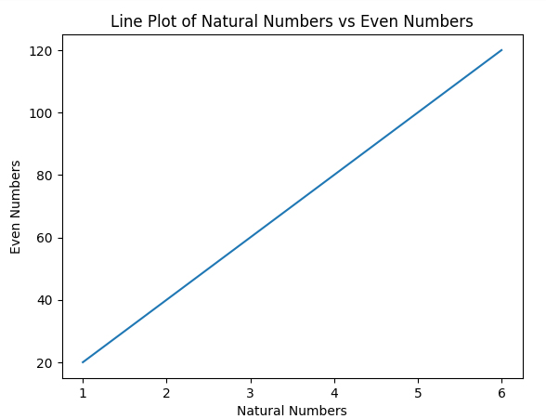

Example No. 02:
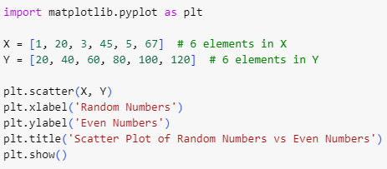
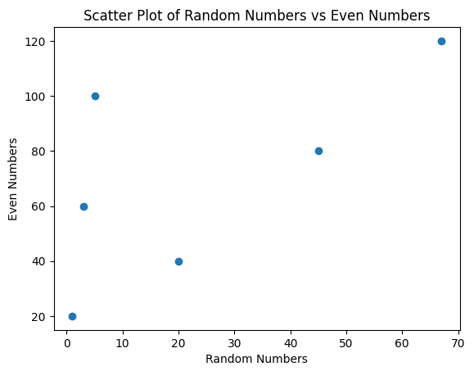

Lab Tasks:
- Create two 1D arrays of size 5 with random integers. Perform element-wise addition, subtraction, multiplication, and division. Print all results neatly.
- Create a 1D NumPy array of 10 random integers between 1 and 50. Display only the even numbers and count them. Find the maximum, minimum, and their indices. (Hint: use argmax() and argmin() for indices)
- Generate a 3×3 matrix of random numbers between 10 and 100. Replace all elements greater than 50 with 0. Print the modified matrix.
- Create a DataFrame with columns: Product, Price, Quantity. Add data for 4 products. Add a new column Total = Price × Quantity. and display the result
- Create a DataFrame of 6 cities with columns: City, Population, Area. Add a new column Density = Population / Area. display them and then display only first three
- Create two lists: days = [1,2,3,4,5], temp_cityA and temp_cityB. Plot both temperature trends on the same graph using different colors and labels. Add title, labels, and legend.
- Create a 4x4 matrix with random integers between 1 and 100. Perform the following operations on the matrix:
- Find the sum of all elements.
- Find the mean and standard deviation.
- Reshape the matrix into a 2x8 matrix and print both the original and reshaped matrices.
- Create a Pandas DataFrame containing information about 5 students including their Name, Age and Marks in 3 subjects. Perform the following operations:
- Calculate and display the total marks for each student.
- Calculate and display the average marks for each subject.
- Input data for the yearly sales of a company (years: 2010-2024) and the corresponding profit. Create a scatter plot to visualize the profit for each year and overlay a line plot to show the trend over time. Add appropriate labels for the axes and a title for the graph.

